- HOME PAGE
Overview: The Oracle Basic Tutorials application allows users to open tutorials using two different navigation methods:
- By selecting a tutorial card from the Home page
- By using the Hamburger Menu and navigating through the Course section
This dual navigation system improves usability and provides flexibility for different types of users.

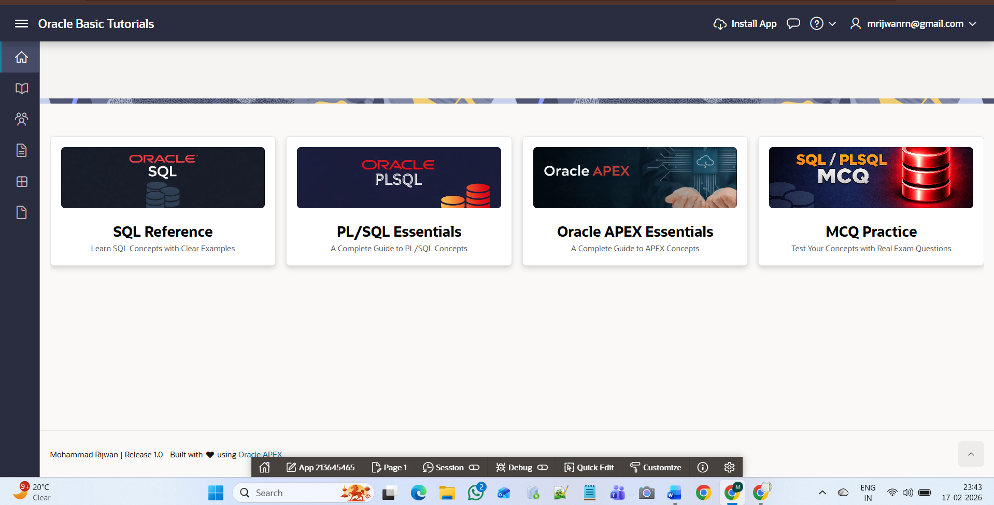

Method 1: Open Tutorial by Selecting a Card
Location: Home Page
- Available Cards:
- SQL Reference
- PL/SQL Essentials
- Oracle APEX Essentials
- MCQ Practice

- Steps:
- Open the application.
- On the Home page, view the available tutorial cards.
- Click on any card.
- System Behaviours
- When a card is clicked, the system redirects the user to the corresponding tutorial page.
- The navigation is handled dynamically using page URLs.
- Each card is linked to its respective tutorial module.
- Advantages:
- Quick access
- User-friendly visual interface
- Ideal for beginners

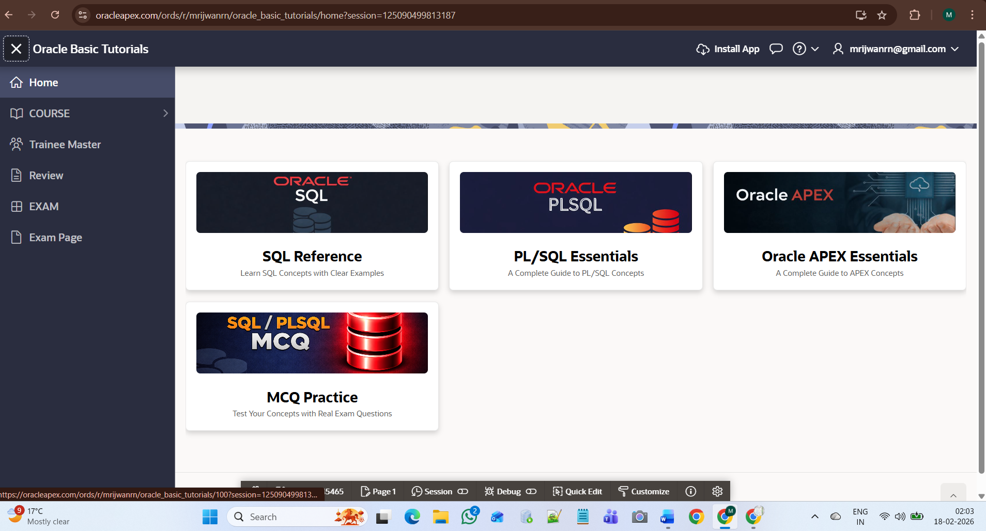

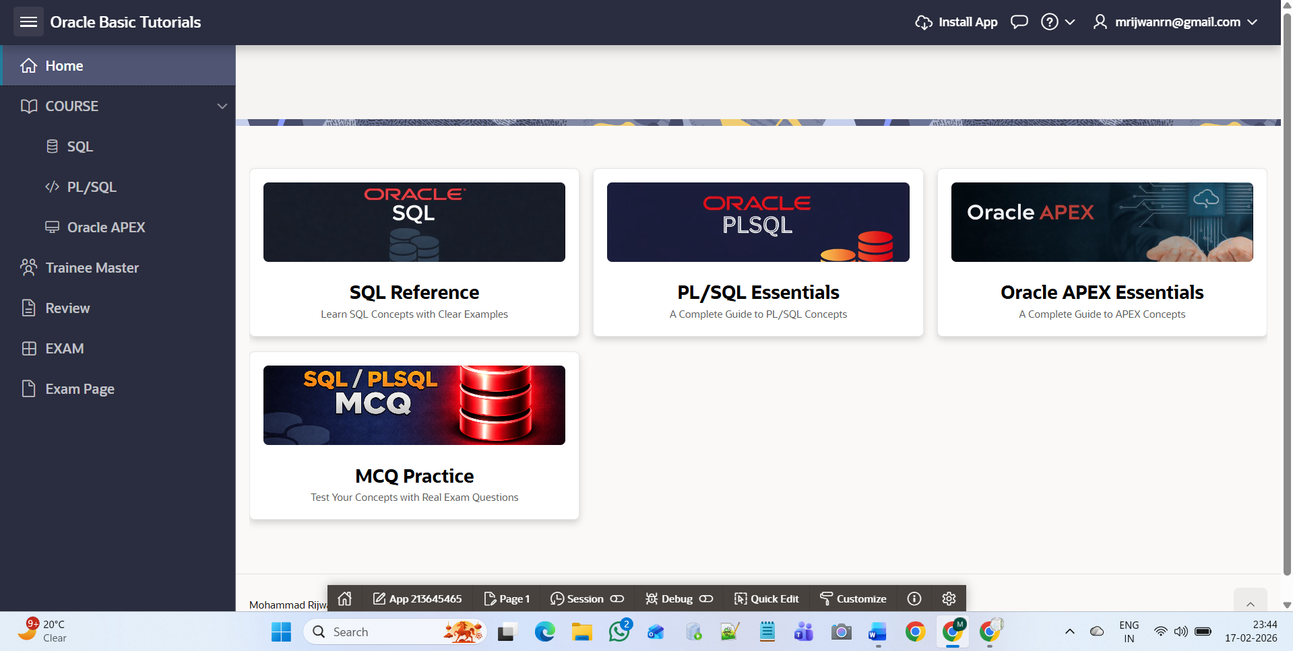

Method 2: Open Tutorial Using Hamburger Menu
Location: Top-left Hamburger Icon (☰)
- Steps:
    - Click the Hamburger icon in the top-left corner.
    - The sidebar menu will open.
    - Click on the COURSE section.
    - Select the required category:
- SQL
- PL/SQL
- Oracle APEX
- System Behaviours:
- The system redirects the user to the selected course listing page.
- This navigation method uses structured menu-based routing.
- Advantages:
  - Organized navigation
  - Direct category access
  - Suitable for regular or advanced users

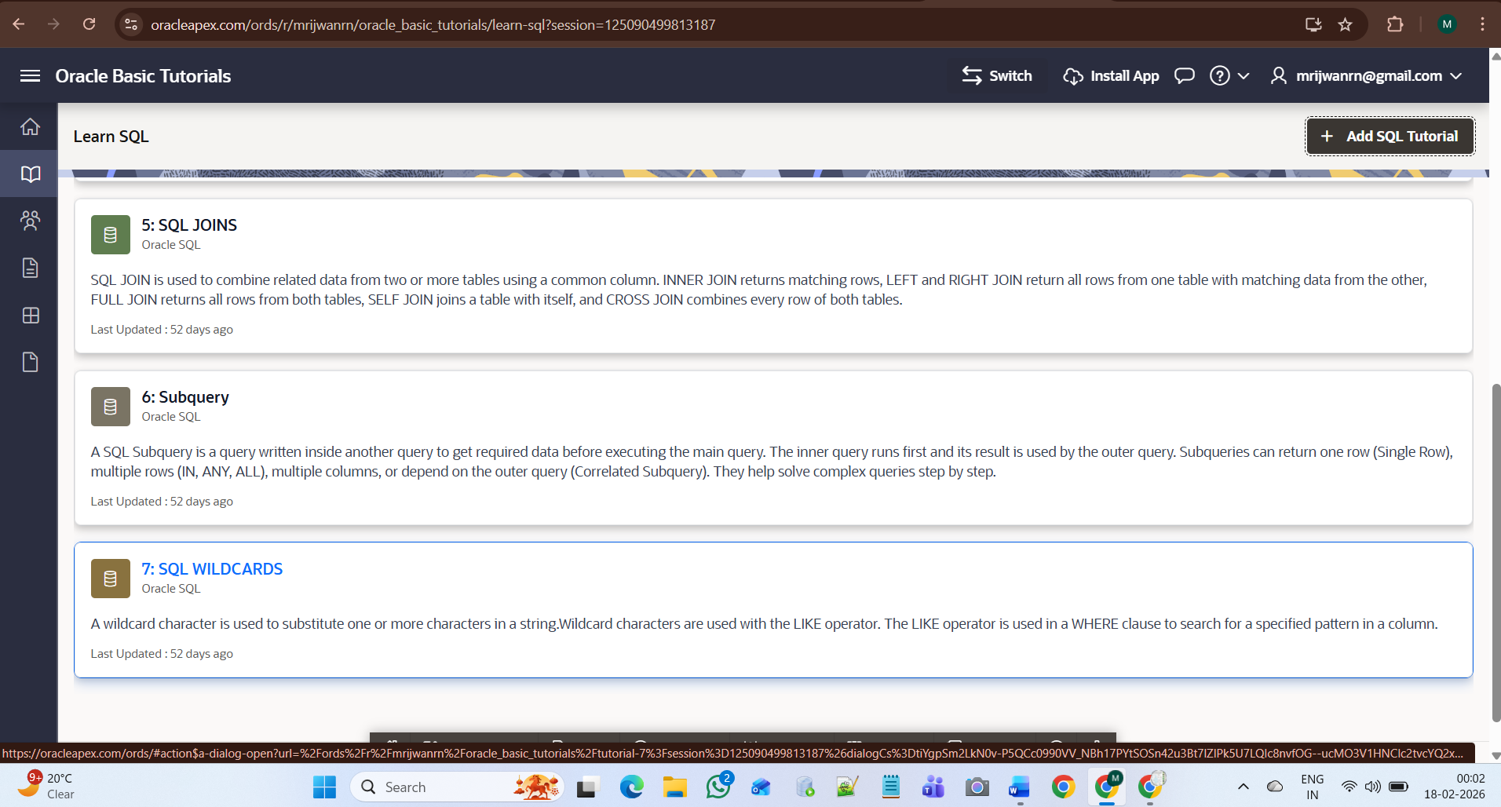

After selecting a course (either from a Home page card or from the Hamburger → Course menu), the system opens a Course Dashboard Page.
- Course Dashboard Page

- When User Clicks:
- SQL Card → Opens SQL Dashboard
- PL/SQL Card → Opens PL/SQL Dashboard
- Oracle APEX Card → Opens APEX Dashboard

- What Appears on Dashboard:
- The page displays:
    - Topic Number
    - Topic Title
    - Summary
    - Last Updated Date
- Each tutorial is displayed in Card Format.
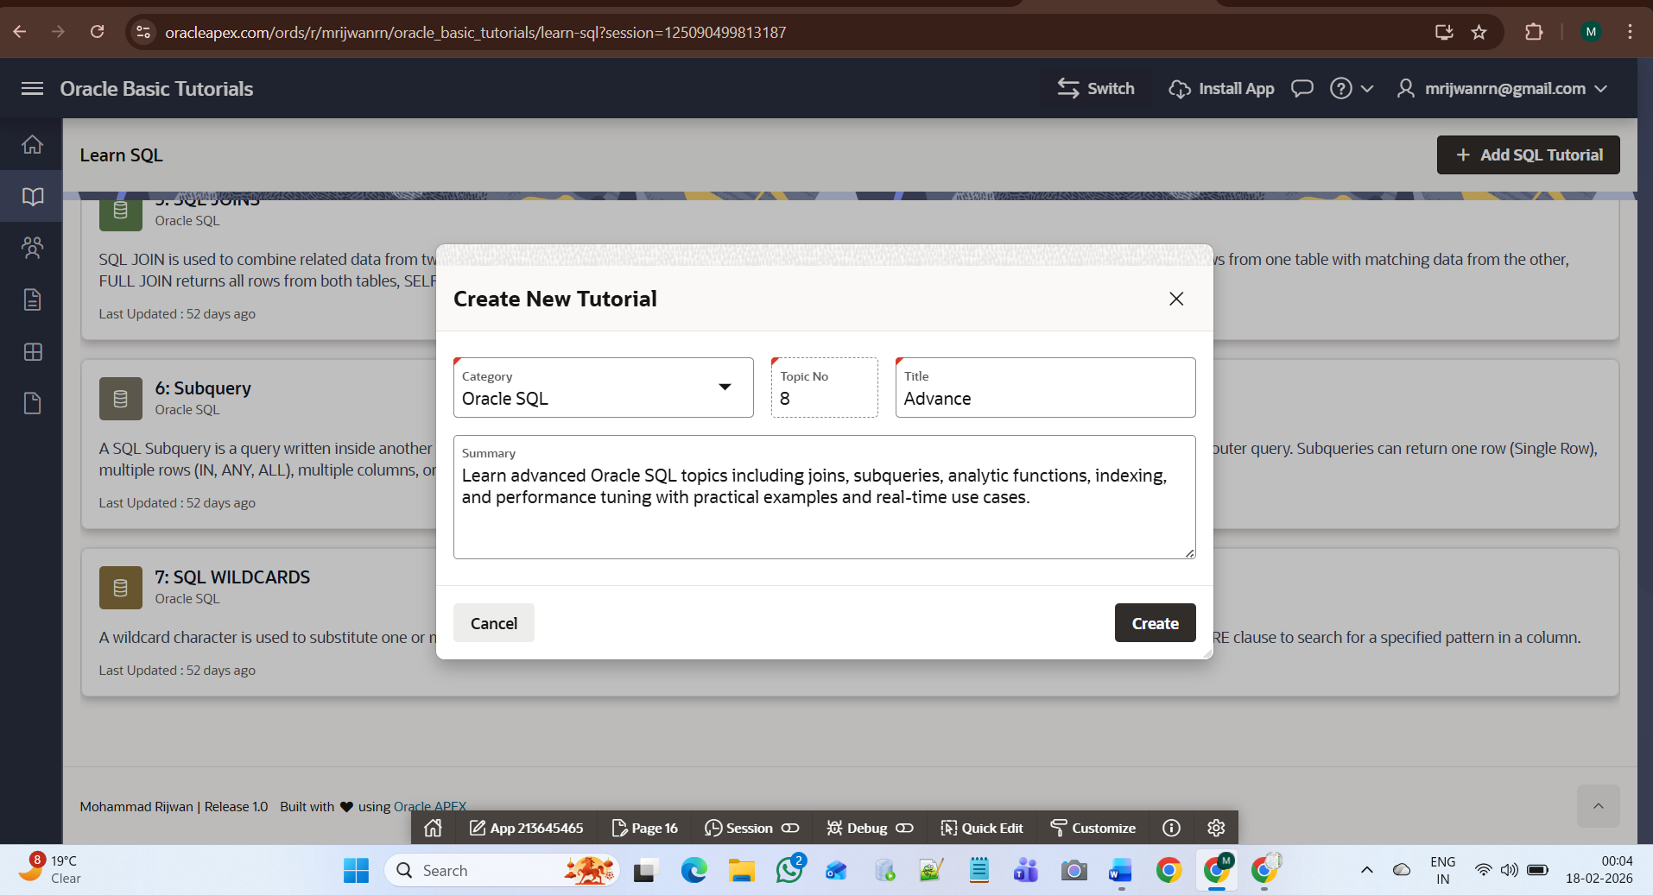

- Adding a New Tutorial
On each Course Dashboard page, a button is available: + Add SQL Tutorial
(or PL/SQL / Oracle APEX depending on category)

- Steps to Add New Tutorial
- Click Add Tutorial button
- A Modal Dialog Form opens
- The form requires:
  - Category (Auto selected)
  - Topic Number (Auto generated)
  - Title (Required)
  - Summary (Required)

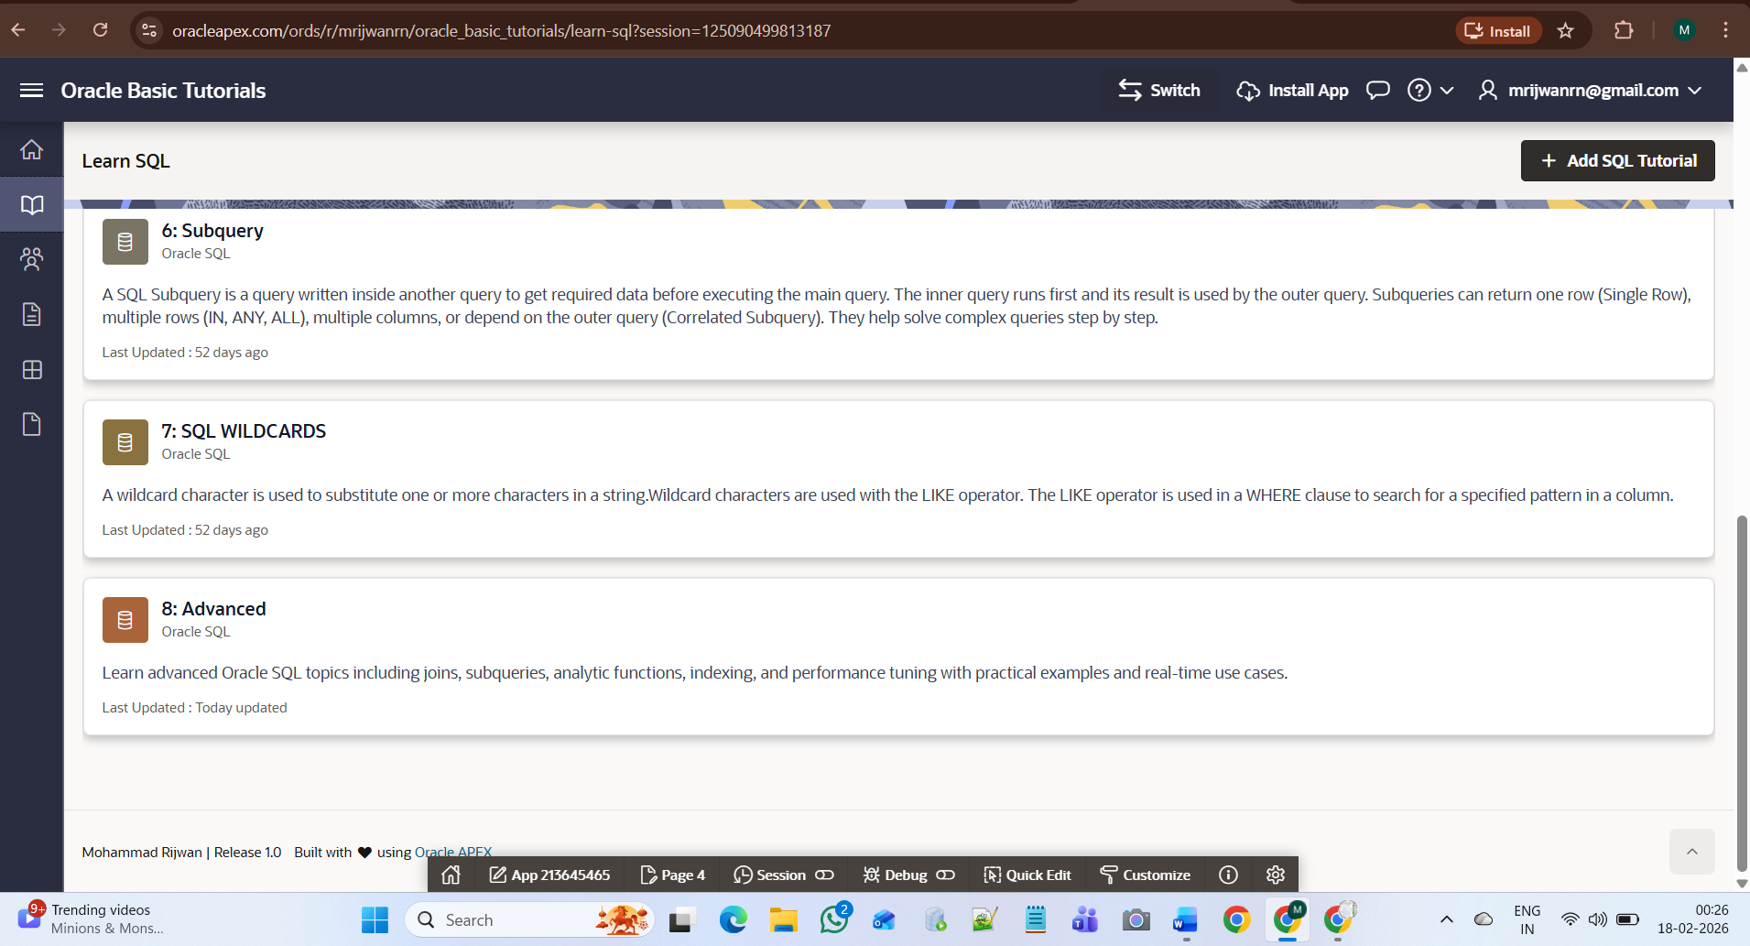

5. Creating the Tutorial
After filling required fields:
- Click Create button
- System performs:
  - Insert record into database
  - Auto assigns next topic number
  - Saves category-wise
- Modal dialog closes
- Dashboard refreshes automatically
- Newly created tutorial appears as a new card
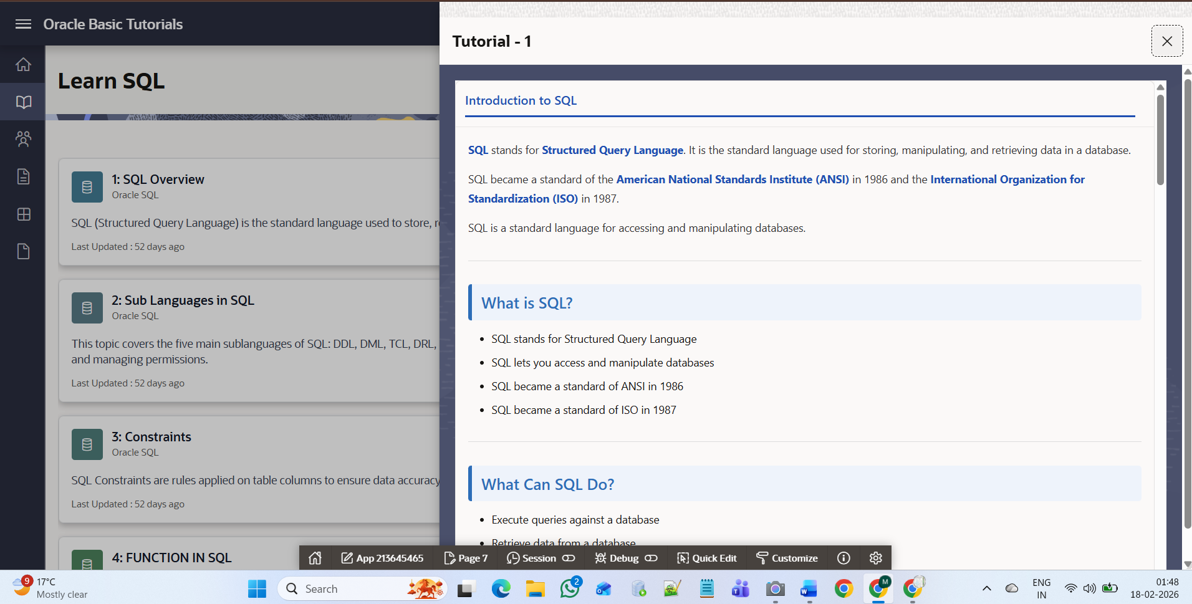
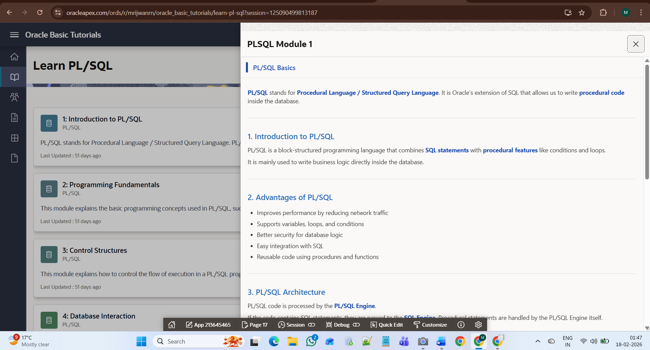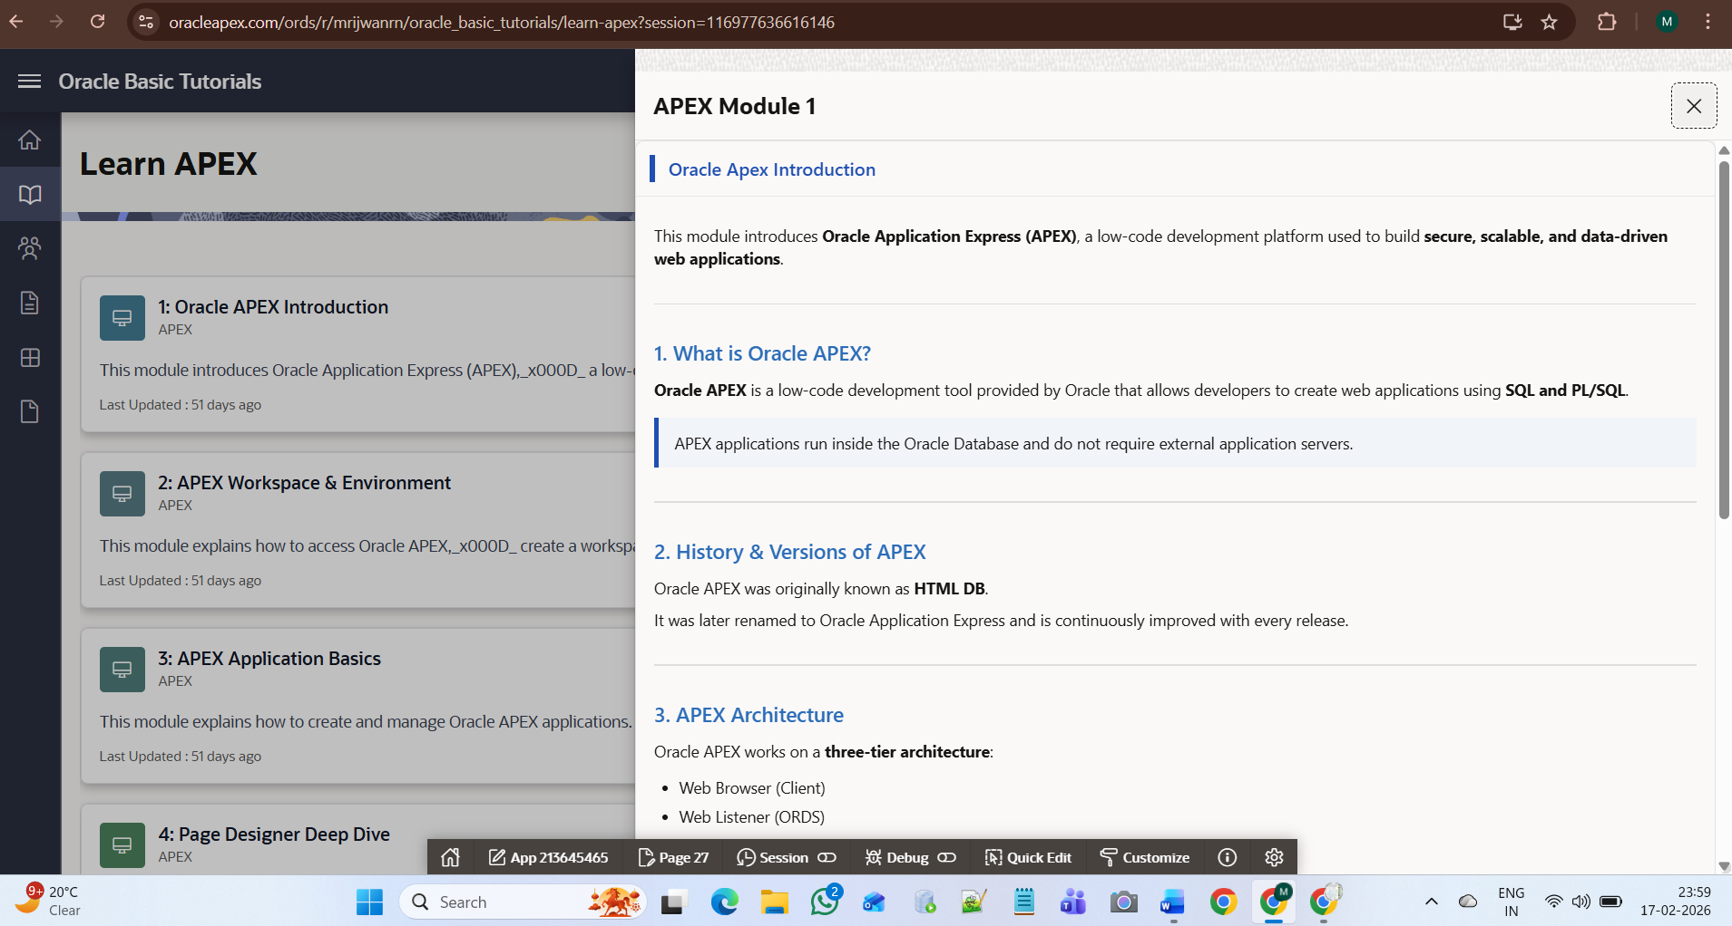

5. Course Tutorial – Detailed View (Drawer Page)
When the user clicks on any course tutorial from the dashboard (SQL, PL/SQL, or Oracle APEX), the system opens the selected tutorial in a drawer panel on the right side of the screen.
The drawer page displays the complete detailed content of the selected tutorial, including:
- Tutorial Title
- Module Name
- Section Headings
- Detailed Explanation
- Structured Content (bullet points, paragraphs, highlights)
The system dynamically fetches the tutorial data from the database using the selected Topic ID. The main dashboard remains visible in the background while the detailed content appears in the sliding drawer.
The drawer includes a close (X) button that allows the user to close the detailed view and return to the course dashboard without reloading the page.
This functionality works consistently for all courses:
- SQL Tutorials
- PL/SQL Tutorials
- Oracle APEX Tutorials
Each tutorial opens its own detailed content based on the selected topic.

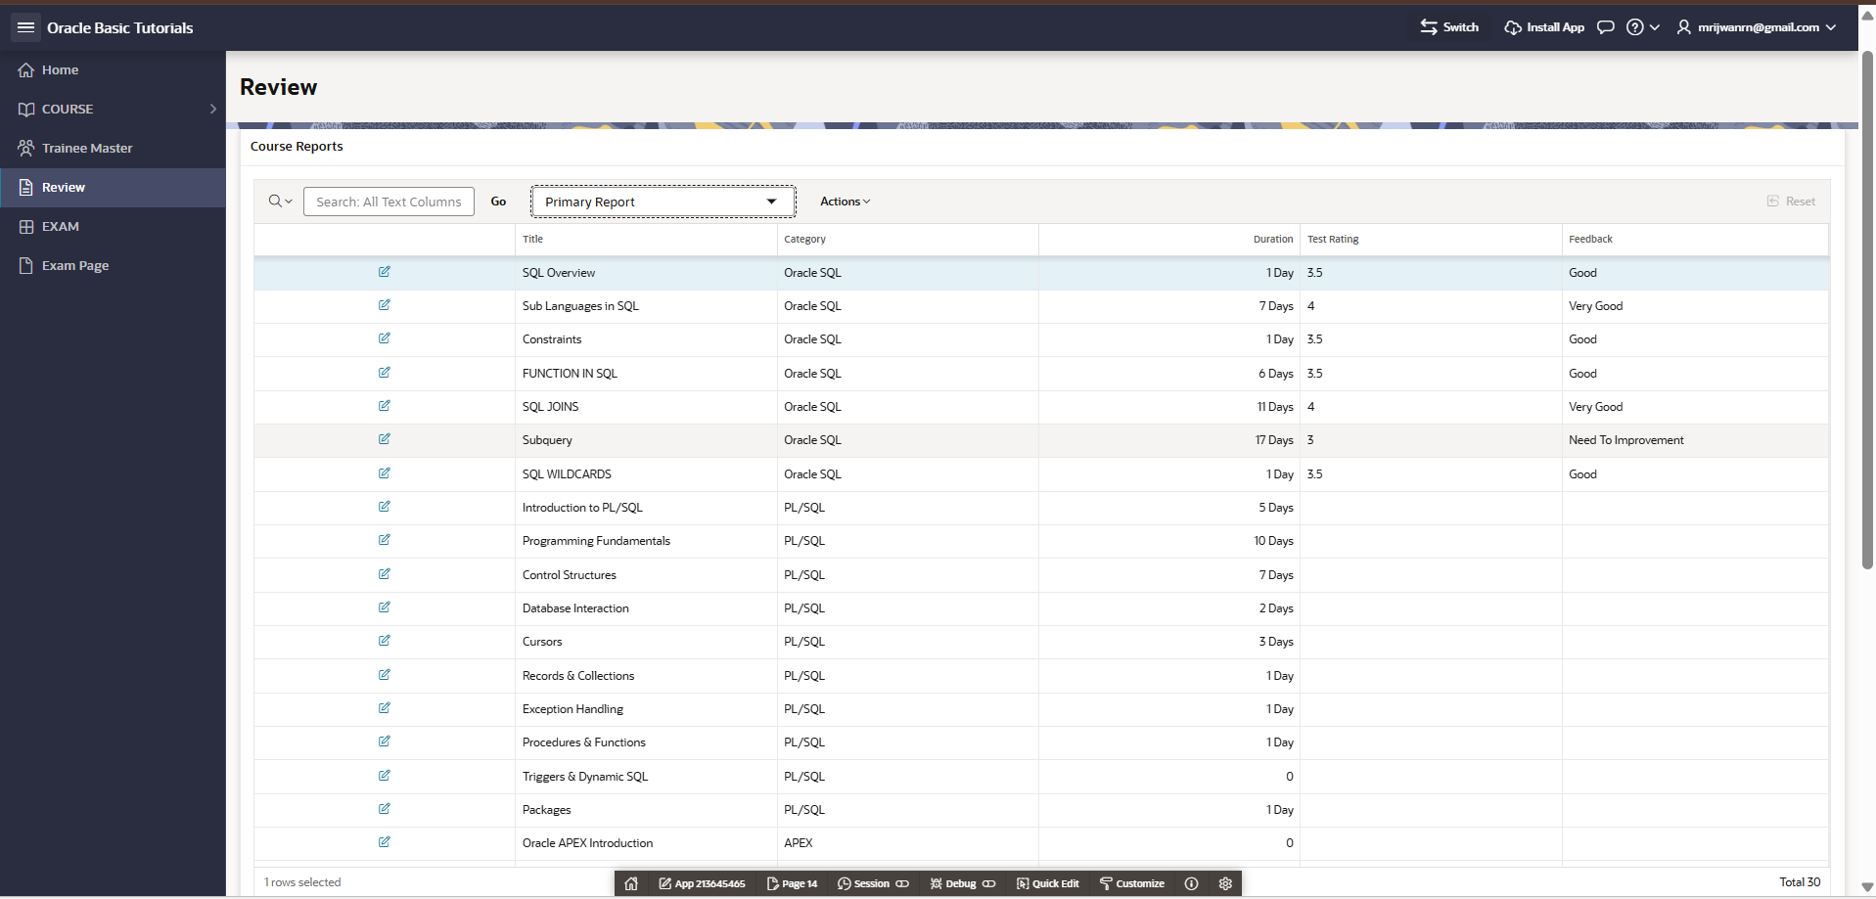

6. Review Module – Test-Based Course Evaluation
Overview
The Review Page provides a structured report of course performance based on user test results and feedback.
This module helps analyse how each tutorial or topic is performing in terms of:
- Learning duration
- Test rating
- User feedback
- Category performance
6.1 Purpose of the Review Page
The Review module is designed to:
- Monitor tutorial effectiveness
- Track user performance
- Evaluate topic quality
- Identify improvement areas
- Provide feedback analysis
It acts as an analytical dashboard for course performance.

6.2 Course Reports Section
The page displays a Primary Report (Interactive Report) containing the following columns:
1. Title
Displays the name of the tutorial or topic.
Example:
- SQL Overview
- Sub Languages in SQL
- Subquery
- Introduction to PL/SQL

2. Category
Indicates which course the tutorial belongs to:
- Oracle SQL
- PL/SQL
- Oracle APEX
3. Duration
Represents the number of days spent or allocated for the topic.
Example:
- 1 Day
- 7 Days
- 17 Days
This helps evaluate the learning timeline.
4. Test Rating
Displays the performance rating of the topic based on test results.
Example:
- 3.5
- 4
- 3
Higher rating indicates better understanding and effectiveness.

5. Feedback
Shows qualitative feedback collected after the test.
Examples:
- Good
- Very Good
- Need To Improvement
This helps measure student satisfaction and topic clarity.

6.3 Functional Features
The Review page includes:
- Search functionality (Search All Text Columns)
- Report filtering options
- Sorting capability
- Actions menu for exporting or customizing reports
- Editable option (if enabled)

6.4 How Review Process Works
- User completes course topic.
- User attempts test or evaluation.
- System calculates rating.
- Feedback is recorded.
- Data is stored in the database.
- Review page fetches and displays updated report.

7. Header Controls & Application Information
7.1 Switch Button
The Switch button is located in the top-right section of the application header.
Functionality:
When the user clicks the Switch button:
- The system redirects the user back to the Home Page (Dashboard).
- It allows quick navigation from any course or tutorial page.
- No data is modified during this action.
- It acts as a global navigation shortcut.
Purpose:
- Provides quick return access to the main dashboard.
- Improves user navigation flow.
- Ensures consistent access to the starting point of the application.

7.2 Install App Button
The Install App button is also located in the top-right header area.
Functionality:
When the user clicks the Install App button:
- The system initiates the Progressive Web App (PWA) installation process.
- The application can be installed on the user’s device (desktop or mobile).
- Once installed, the application behaves like a native application.
- It can be accessed directly from the home screen or desktop shortcut.
Benefits:
- Offline-style experience
- Faster loading
- App-like interface
- Improved accessibility

7.3 Release Information (Footer Section)
At the bottom of the application, the footer displays release information.
Components Explained:
- Developer Name: Mohammad RIJWAN
- Release Version: 1.0
- Technology Used: Oracle APEX
Purpose:
- Identifies the application version.
- Provides developer attribution.
- Displays platform acknowledgment.
- Helps track application updates and future releases.

Final Application Summary
The Oracle Basic Tutorials application includes:
- Dual navigation system (Card & Sidebar)
- Dynamic course dashboards
- Modal-based tutorial creation
- Drawer-based detailed content view
- Header navigation controls (Switch, Install)
- Release tracking and version display
This ensures a complete, structured, and scalable tutorial management system built using Oracle APEX.

